Experiment 31 – Factorial Using Recursion
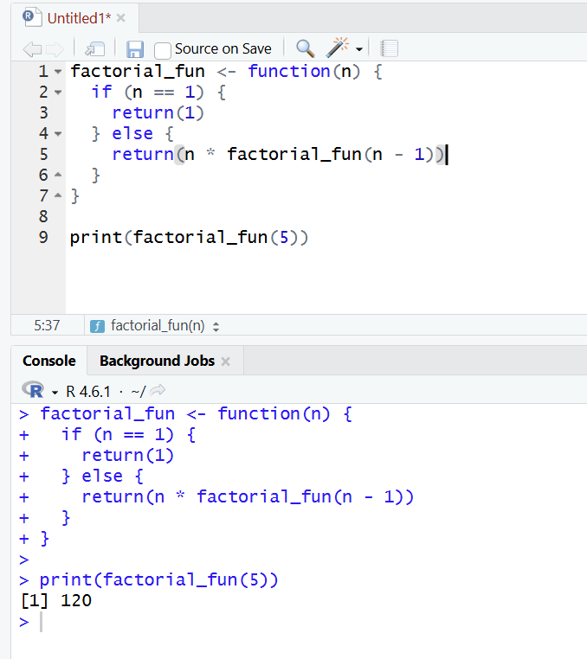

Experiment 32 – Fibonacci Series Using Recursion
